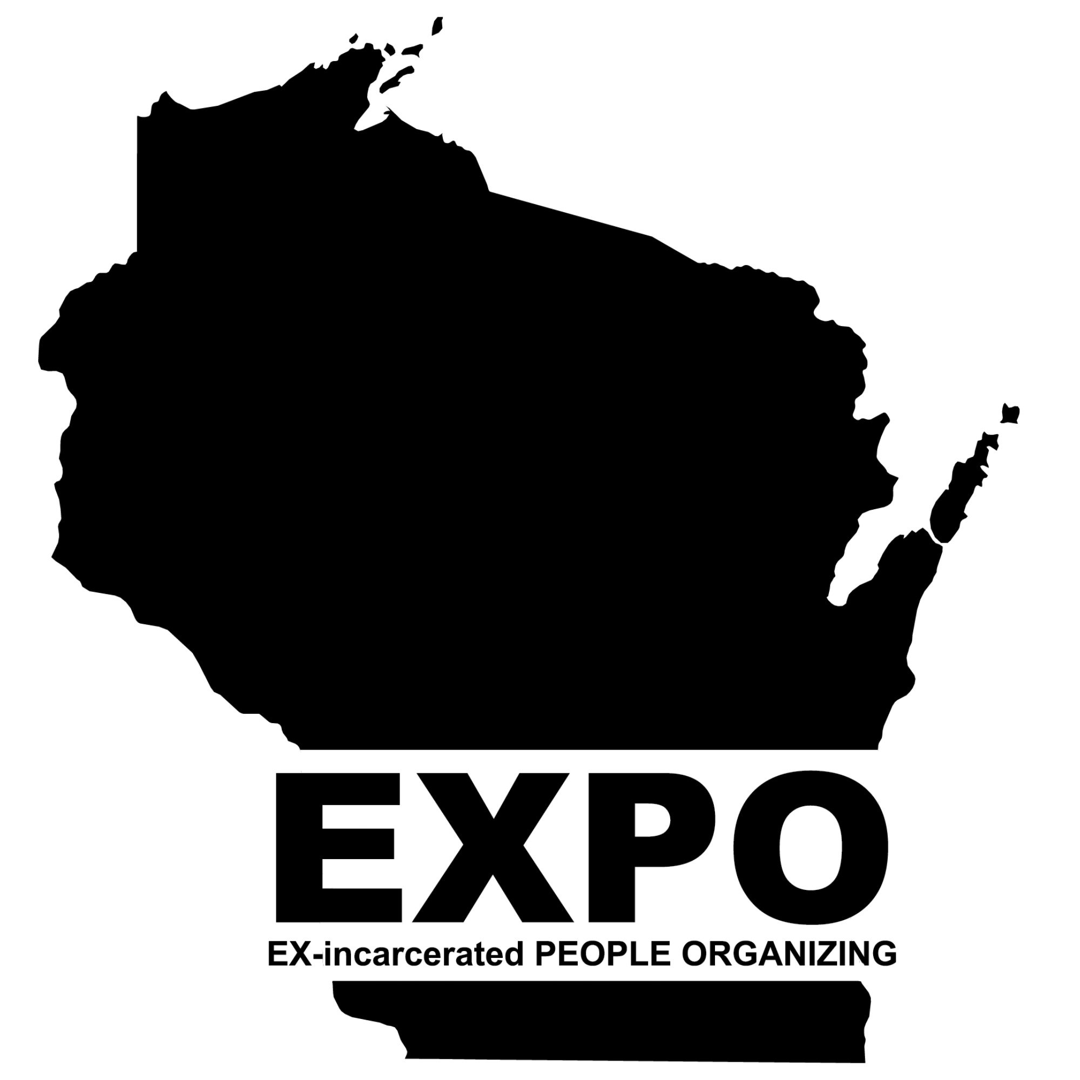
Locked Up on The Outside: Excessive Supervision
Over 43 states have time limits on how long a person with a felony conviction can be put on parole, probation, or extended supervision, including some of Wisconsin's neighboring states. Wisconsin has no restrictions on how long a person can be placed on supervision once released from prison. The lack of regulation has led to excessive supervision sentences, resulting in many Wisconsinites being under supervision for longer than they served in penal institutions.
The Department of Corrections Division of Community Corrections released its 2022 yearly report showing that 51,018 Wisconsinites are under supervision. 51,018 Wisconsin residents are being disenfranchised and are constantly fearful of returning to prison due to violations of their conditions of release. The prison policy initiative found that "when people on supervision are incarcerated, it's usually for breaking a rule, not committing a new crime. EXPO's initiative Locked Up on The Outside aims to bring awareness to the harmful effects of excessive supervision and push forward legislation that will limit the amount of time someone with a felony conviction can be on supervision. The report below will detail our neighboring state's laws that restrict supervision terms and highlights legislation Wisconsin can model.
Minnesota
The Minnesota state legislature will review House File 1607 during the 2023-2024 regular session. The Minnesota Sentencing Guidelines Commission in 2020 changed the maximum time a person could serve on probation to five years except in cases of homicide and criminal sexual conduct. HF1607 will codify the actions of the Sentencing Guidelines Commission. It will also make these changes retroactive and allow Minnesota residents subjected to excessive probation terms to be relieved of their sentences.
According to Rep. Jamie Long, who has sponsored HF1607, the average Minnesota probation term is longer than the average prison term, and these excessive terms can make it hard to keep a job, restrict civil rights, and are ineffective since most probation revocations happen in the first three years after being released. A five-year maximum will allow people to regain voting rights, hold steady employment, and be more effective at targeting revocation.
Iowa
Under Iowa's code Chapter 907.7 Length of Probation, probation should not exceed five years for felony offenses and two years for misdemeanor offenses. The term of parole in Iowa must equal the period of imprisonment but can not extend beyond this time. Therefore someone can spend less time on supervision than their time in prison. Iowa is one of Wisconsin's peer states and has passed monumental criminal justice reform in recent years, which can be modeled in Wisconsin. Minnesota legislators, including Rep. Jamie Long, cited Iowa's probation term limits in the proposal of HF1607.
Illinois
Illinois has restrictions on the amount of time a person with a felony conviction can serve on probation, depending on the class of the felony. Class one and two felonies have a four-year probation cap, but some class one felonies are not eligible for probation, such as residential burglary. Any person with a class three and four felony conviction can not be subjected to more than two and half years of probation. In 2021, the Illinois legislature passed the SAFE-T Act, which improved conditions for people on mandatory supervised release (Parole) by reducing the amount of time someone must serve based on the offense class.
Michigan
Michigan's Code of Criminal Procedure states that a person with a felony conviction can not have a probation period that exceeds three years. Once someone has served the minimum portion of their sentence, they can become eligible for parole. Once the Michigan Parole Board approves them, these individuals typically spend one to four years on parole. Michigan courts can extend probation terms for one additional year no more than two times if the court feels a rehabilitation goal has not been met. In a report by Recidiviz, the reduction from a five-year maximum probation sentence to three years could save the state 29.6 million dollars in avoided probation costs over the next five years. Recidiviz also found that in 2018 24% of Michigan's new prison commitments were due to probation violations.
Healthier, Safer, and Smarter for Wisconsin
The Wisconsin ACLU Smart Justice report states that crimeless revocations, which are technical violations such as accepting employment without prior approval, borrowing money, or missing an appointment, account for 37% of all Wisconsin Prisons admissions as of 2017. These prison admissions cost the state roughly $147.5 million. Wisconsin staffing shortages disproportionately impact The Wisconsin Department of Corrections employees; supervision caps will allow this system to be less burdened by technical violations, directly impacting DOC staff, and enable staff to perform their duties more effectively. The system will be less overwhelming and less stressful, improving DOC staff's and their family's health and well-being as well as those they serve.
Reducing the time a person with a felony conviction spends on parole, probation, and extended supervision will allow individuals to no longer be at risk of being re-incarcerated for technical violations and reduce the hidden costs of this practice, which breaks familial systemic involvement. People incarcerated on these violations can not be taxed, are very costly to the state, and miss out on necessary time with their families and communities. It will also save the state millions of dollars on prison costs which can be reallocated to other sectors to improve Wisconsin neighborhoods, such as education, substance abuse treatment, and supportive services for DOC staff. These limits on supervision will also allow formerly incarcerated individuals to re-enter the communities, regain their civil rights, and maintain their households by being able to have steady employment and housing without fear of their progress being undermined by revocation investigations.

EXPO of Wisconsin
17 Applegate Court
Suite 202
Madison, WI 53813

info@expowisconsin.org

www.expowisconsin.org

Citations

Wisconsin
https://doc.wi.gov/DataResearch/DataAndReports/DCCYearInReview.pdf
https://www.aclu-wi.org/sites/default/files/field_documents/crimeless_revocation_in_wisconsin.pdf

Minnesota
https://www.house.mn.gov/bills/Info/HF1607/93/2023/0
https://www.youtube.com/watch?v=VkdntT78d0w
https://www.startribune.com/sentencing-guidelines-commission-votes-to-approve-5-year-felony-probation-cap/566852112/

Iowa
https://www.legis.iowa.gov/docs/ico/chapter/907.pdf
https://www.legis.iowa.gov/docs/ico/chapter/906.pdf

Michigan
https://assets.website-files.com/5e7ff048d75a9b3c5df52463/5ffde3e34a49eeaaee58385b_MI_probationcaps.pdf
https://www.legislature.mi.gov/(S(0wwmucfbvif431pjlzbghnln))/mileg.aspx?page=getObject&objectname=mcl-771-2
https://www.michigan.gov/corrections/parole-probation#:~:text=Prisoners%20who%20have%20been%20incarcerated,of%20one%20to%20four%20years.

Illinois
https://www.criminallawyerillinois.com/2021/07/12/illinois-law-on-felony-probation-sentences-generally/
https://www.criminallawyerillinois.com/2021/08/09/summary-of-felony-prison-sentences/
https://icjia.illinois.gov/researchhub/articles/the-2021-safe-t-act-icjia-roles-and-responsibilities

